- Bond market, yield curve
The bond market—often called the debt market, fixed-income market, or credit market—is the collective name given to all trades and issues of debt securities. Governments typically issue bonds in order to raise capital to pay down debts or fund infrastructural improvements.
Publicly traded companies issue bonds when they need to finance business expansion projects or maintain ongoing operations.
An interest rate is what someone pays to a lender for borrowing money. This means that you pay interest to borrow money and you can also earn interest when you invest money in certain assets, such as bonds or savings accounts.
Most bonds have an interest rate that determines their coupon payments, but the true cost of borrowing or investing in bonds is determined by their current bond yields. The bond yield is the return an investor realizes on a bond. It can be conceptualized as the discount rate that can be used to make the present value of all of a bond's cash flows equal to its price. A bond's price is the sum of the present value of all cash flow that will ever be received from the investment.
Bond pricing: To calculate the cash price of a bond we discount each cash flow at the appropriate zero rate (A zero rate (or spot rate), for maturity T is the rate of interest earned on an investment that provides a payoff only at time T)
The bond yield is the discount rate that makes the present value of the cash flows on the bond equal to the market price of the bond
The return from a bond is commonly measured as yield-to-maturity (YTM). That's the total annualized return an investor receives assuming the bond is held until it matures and the coupon payments are reinvested. YTM provides a standard annualized measure of return for a particular bond. If coupon rate < than YTM then bond value < than notion and vice versa.
Treasury rates are the rates an investor earns on Treasury bills and Treasury bonds. These are the instruments used by a government to borrow in its own currency.
Duration of a bond measure of how long on average the holder of the bond has to wait before receiving cash payments

Short-Term vs. Long-Term Interest Rates
Bonds come with a variety of maturity periods from as little as one month to 30 years. Bonds with longer terms tend to come with better interest rates. It's important to understand that there are short-term interest rates, long-term interest rates, and many points in between. While all rates correlate, they don't always move in step. Short-term rates might fall while long-term interest rates rise and vice versa.
The benchmarks for short-term interest rates are set by each nation's central bank.
Long-term interest rates are determined by market forces. These forces are primarily at work in the bond market. If the market senses that the fed funds rate is too low, expectations of future inflation will rise. Long-term interest rates will go up to compensate for the perceived loss of purchasing power associated with the future cash flow of a bond or a loan.
Reading the Yield Curve
Yield curves plot interest rates of bonds of equal credit and different maturities. The three key types of yield curves include normal, inverted, and flat. Upward sloping (also known as normal yield curves) is where longer-term bonds have higher yields than short-term ones.
Types of Yield Curves
There are several distinct formations of yield curves: normal (with a steep variation), inverted, and flat.
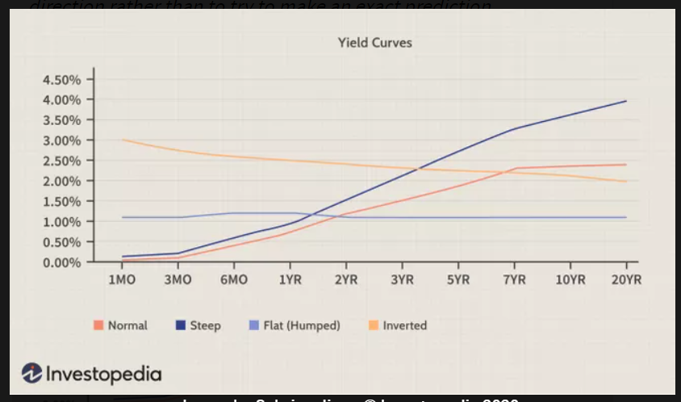
Normal Yield Curve
A normal yield curve starts with low yields for lower maturity bonds and then increases for bonds with higher maturity. A normal yield curve slopes upwards. Once bonds reach the highest maturities, the yield flattens and remains consistent. This is the most common type of yield curve. Longer maturity bonds usually have a higher yield to maturity than shorter-term bonds.

Steep Yield Curve
It is shaped like a normal yield curve with two major differences. First, the higher maturity yields don’t flatten out at the right but continue to rise. Second, the yields are usually higher compared to the normal curve across all maturities.
Such a curve implies a growing economy moving towards a positive upturn. Such conditions are accompanied by higher inflation, which often results in higher interest rates. Lenders tend to demand high yields, which get reflected by the steep yield curve. Longer-duration bonds become risky, so the expected yields are higher.
Flat Yield Curve
A flat yield curve, also called a humped yield curve, shows similar yields across all maturities. A few intermediate maturities may have slightly higher yields, which causes a slight hump to appear along the flat curve. These humps are usually for the mid-term maturities, six months to two years.
It implies an uncertain economic situation. It may come at the end of a high economic growth period that is leading to inflation and fears of a slowdown. It might appear at times when the central bank is expected to increase interest rates. In times of high uncertainty, investors demand similar yields across all maturities.
Inverted Yield Curve
The shape of the inverted yield curve is opposite to that of a normal yield curve. It slopes downward. An inverted yield curve means that short-term interest rates exceed long-term rates.
A severe economic slowdown. Historically, the impact of an inverted yield curve has been to warn that a recession is coming.
- Measuring and managing interest rate risk

What Is Interest Rate Risk?
Interest rate risk is the potential for investment losses that result from a change in interest rates. If interest rates rise, for instance, the value of a bond or other fixed-income investment will decline. The change in a bond's price given a change in interest rates is known as its duration.
Interest rate risk can be reduced by holding bonds of different durations, and investors may also allay interest rate risk by hedging fixed-income investments with interest rate swaps, options, or other interest rate derivatives.
Understanding Interest Rate Risk
Interest rate changes can affect many investments, but it impacts the value of bonds and other fixed-income securities most directly. Bondholders, therefore, carefully monitor interest rates and make decisions based on how interest rates are perceived to change over time.
For fixed-income securities, as interest rates rise security prices fall (and vice versa). This is because when interest rates increase, the opportunity cost of holding those bonds increases – that is, the cost of missing out on an even better investment is greater.
Therefore, for bonds that have a fixed rate, when interest rates rise to a point above that fixed level, investors switch to investments that reflect the higher interest rate. Securities that were issued before the interest rate change can compete with new issues only by dropping their prices.

Example of Interest Rate Risk
For example, say an investor buys a five-year, $500 bond with a 3% coupon. Then, interest rates rise to 4%. The investor will have trouble selling the bond when newer bond offerings with more attractive rates enter the market. The lower demand also triggers lower prices on the secondary market. The market value of the bond may drop below its original purchase price.
The reverse is also true. A bond yielding a 5% return holds more value if interest rates decrease below this level since the bondholder receives a favorable fixed rate of return relative to the market.

Bond Price Sensitivity
The value of existing fixed-income securities with different maturity dates declines by varying degrees when market interest rates rise. This phenomenon is referred to as “price sensitivity” and is measured by the bond's duration.
For instance, suppose there are two fixed-income securities, one that matures in one year and another that matures in 10 years. When market interest rates rise, the owner of the one-year security can reinvest in a higher-rate security after hanging onto the bond with a lower return for only one year at most. But the owner of the 10-year security is stuck with a lower rate for nine more years.
That justifies a lower price value for the longer-term security. The longer a security's time to maturity, the more its price declines relative to a given increase in interest rates.

The Maturity Risk Premium
A long-term bond generally offers a maturity risk premium in the form of a higher built-in rate of return to compensate for the added risk of interest rate changes over time. The larger duration of longer-term securities means higher interest rate risk for those securities. To compensate investors for taking on more risk, the expected rates of return on longer-term securities are typically higher than rates on shorter-term securities. This is known as the maturity risk premium.
Other risk premiums, such as default risk premiums and liquidity risk premiums, may determine rates offered on bonds.
How to Mitigate Interest Rate Risk
Similar to other types of risks, the interest rate risk can be mitigated. The most common tools for interest rate mitigation include:
1. Diversification
If a bondholder is afraid of interest rate risk that can negatively affect the value of his portfolio, he can diversify his existing portfolio by adding securities whose value is less prone to the interest rate fluctuations (e.g., equity). If the investor has a “bonds only” portfolio, he can diversify the portfolio by including a mix of short-term and long-term bonds.
2. Hedging
The interest rate risk can also be mitigated through various hedging strategies. These strategies generally include the purchase of different types of derivatives. The most common examples include interest rate swaps, options, futures, and forward rate agreements (FRAs).

Forwards: A forward contract is the most basic interest rate management product. The idea is simple, and many other products discussed in this article are based on this idea of an agreement today for an exchange of something at a specific future date.
Forward Rate Agreements (FRAs): An FRA is based on the idea of a forward contract, where the determinant of gain or loss is an interest rate. Under this agreement, one party pays a fixed interest rate and receives a floating interest rate equal to a reference rate. The actual payments are calculated based on a notional principal amount and paid at intervals determined by the parties. Only a net payment is made—the loser pays the winner, so to speak. FRAs are always settled in cash.
FRA users are typically borrowers or lenders with a single future date on which they are exposed to interest rate risk. A series of FRAs is similar to a swap (discussed below); however, in a swap, all payments are at the same rate. Each FRA in a series is priced at a different rate unless the term structure is flat.
Futures: A futures contract is similar to a forward, but it provides the counterparties with less risk than a forward contract—namely, a lessening of default and liquidity risk due to the inclusion of an intermediary.
Swaps: Just like it sounds, a swap is an exchange. More specifically, an interest rate swap looks a lot like a combination of FRAs and involves an agreement between counterparties to exchange sets of future cash flows. The most common type of interest rate swap is a plain vanilla swap, which involves one party paying a fixed interest rate and receiving a floating rate, and the other party paying a floating rate and receiving a fixed rate.
Options: Interest rate management options are option contracts for which the underlying security is a debt obligation. These instruments are useful in protecting the parties involved in a floating-rate loan, such as adjustable-rate mortgages (ARMs). A grouping of interest rate call options is referred to as an interest rate cap; a combination of interest rate put options is referred to as an interest rate floor. In general, a cap is like a call, and a floor is like a put.
- Portfolio theory, CAPM, APT
What Is the Capital Asset Pricing Model?
The capital asset pricing model (CAPM) is a model that can be used to calculate the expected return from an asset during a period in terms of the risk of the return. The risk in the return from an asset is divided into two parts. Systematic risk is risk related to the return from the market as a whole and cannot be diversified away. Nonsystematic risk is risk that is unique to the asset and can be diversified away by choosing a large portfolio of different assets. CAPM argues that the return should depend only on systematic risk.
Capital Asset Pricing Model (CAPM)
The formula for calculating the expected return of an asset given its risk is as follows:
ERi​=Rf​+βi​(ERm​−Rf​)
where:
ERi​=expected (average) return of investment
Rf​=risk-free rate (US treasury)
βi​=beta of the investment is a parameter measuring systematic risk.
(ERm​−Rf​)=market risk premium​
Investors expect to be compensated for risk and the time value of money. The risk-free rate in the CAPM formula accounts for the time value of money. The other components of the CAPM formula account for the investor taking on additional risk.
The beta of a potential investment is a measure of how much risk the investment will add to a portfolio that looks like the market. If a stock is riskier than the market, it will have a beta greater than one. If a stock has a beta of less than one, the formula assumes it will reduce the risk of a portfolio.
A stock’s beta is then multiplied by the market risk premium, which is the return expected from the market above the risk-free rate. The risk-free rate is then added to the product of the stock’s beta and the market risk premium. The result should give an investor the required return or discount rate they can use to find the value of an asset.
The goal of the CAPM formula is to evaluate whether a stock is fairly valued when its risk and the time value of money are compared to its expected return.
Problems With the CAPM
There are several assumptions behind the CAPM formula that have been shown not to hold in reality. Modern financial theory rests on two assumptions: One, securities markets are very competitive and efficient (that is, relevant information about the companies is quickly and universally distributed and absorbed) and two, these markets are dominated by rational, risk-averse investors, who seek to maximize satisfaction from returns on their investments.
Including beta in the formula assumes that risk can be measured by a stock’s price volatility. However, price movements in both directions are not equally risky. The look-back period to determine a stock’s volatility is not standard because stock returns (and risk) are not normally distributed.
The CAPM also assumes that the risk-free rate will remain constant over the discounting period. Assume that the interest rate on U.S. Treasury bonds rose to 5% or 6% during the 10-year holding period. An increase in the risk-free rate also increases the cost of the capital used in the investment and could make the stock look overvalued.
The market portfolio that is used to find the market risk premium is only a theoretical value and is not an asset that can be purchased or invested in as an alternative to the stock. Most of the time, investors will use a major stock index, like the S&P 500, to substitute for the market, which is an imperfect comparison.
The most serious critique of the CAPM is the assumption that future cash flows can be estimated for the discounting process. If an investor could estimate the future return of a stock with a high level of accuracy, the CAPM would not be necessary.
The CAPM and the Efficient Frontier
Using the CAPM to build a portfolio is supposed to help an investor manage their risk. If an investor were able to use the CAPM to perfectly optimize a portfolio’s return relative to risk, it would exist on a curve called the efficient frontier, as shown in the following graph.

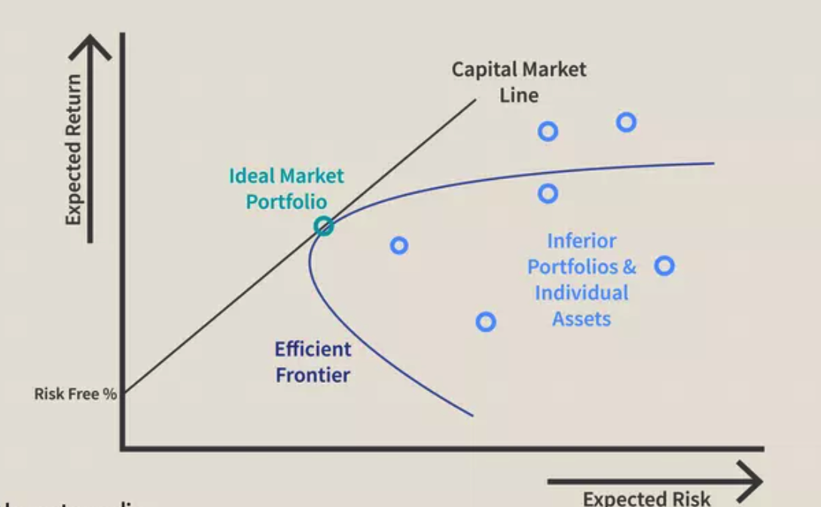

The graph shows how greater expected returns (y-axis) require greater expected risk (x-axis). Modern Portfolio Theory (MPT) suggests that starting with the risk-free rate, the expected return of a portfolio increases as the risk increases. Any portfolio that fits on the Capital Market Line (CML) is better than any possible portfolio to the right of that line, but at some point, a theoretical portfolio can be constructed on the CML with the best return for the amount of risk being taken.

The CML and efficient frontier may be difficult to define, but it illustrates an important concept for investors: there is a trade-off between increased return and increased risk. Because it isn’t possible to perfectly build a portfolio that fits on the CML, it is more common for investors to take on too much risk as they seek additional return.
The efficient frontier assumes the same things as the CAPM and can only be calculated in theory. If a portfolio existed on the efficient frontier it would be providing the maximal return for its level of risk. However, it is impossible to know whether a portfolio exists on the efficient frontier or not because future returns cannot be predicted.
This trade-off between risk and return applies to the CAPM and the efficient frontier graph can be rearranged to illustrate the trade-off for individual assets. In the following chart, you can see that the CML is now called the Security Market Line (SML). Instead of expected risk on the x-axis, the stock’s beta is used. As you can see in the illustration, as beta increases from one to two, the expected return is also rising.
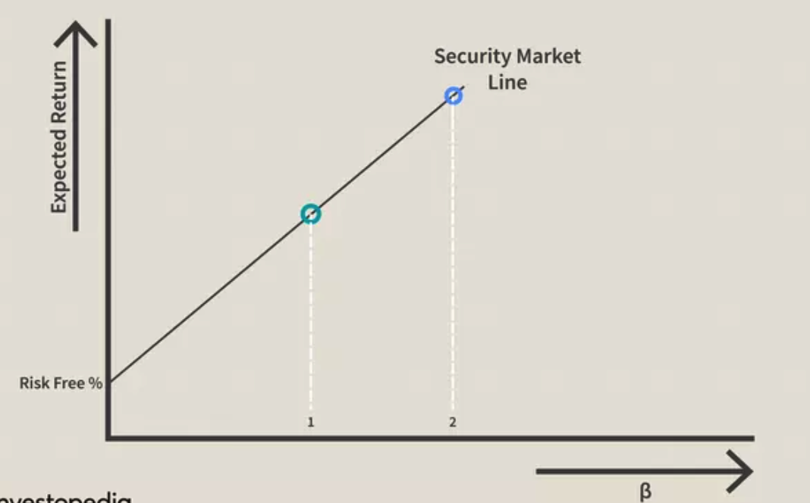

The CAPM and SML make a connection between a stock’s beta and its expected risk. A higher beta means more risk but a portfolio of high beta stocks could exist somewhere on the CML where the trade-off is acceptable, if not the theoretical ideal.
The value of these two models is diminished by assumptions about beta and market participants that aren’t true in the real markets. For example, beta does not account for the relative riskiness of a stock that is more volatile than the market with a high frequency of downside shocks compared to another stock with an equally high beta that does not experience the same kind of price movements to the downside.
What Is the Arbitrage Pricing Theory (APT)?
Arbitrage pricing theory (APT) is a multi-factor asset pricing model based on the idea that an asset's returns can be predicted using the linear relationship between the asset’s expected return and a number of macroeconomic variables that capture systematic risk. It is a useful tool for analyzing portfolios from a value investing perspective, in order to identify securities that may be temporarily mispriced.

The Formula for the Arbitrage Pricing Theory Model Is
​ ​E(R)i​=E(R)z​+(E(I)−E(R)z​)×βn
​where:
E(R)i​=Expected return on the asset
Rz​=Risk-free rate of return
βn=Sensitivity of the asset price to macro economic factor n
Ei=Risk premium associated with factor i​
How the Arbitrage Pricing Theory Works

Unlike the CAPM, which assume markets are perfectly efficient, APT assumes markets sometimes misprice securities, before the market eventually corrects and securities move back to fair value. Using APT, arbitrageurs hope to take advantage of any deviations from fair market value.
However, this is not a risk-free operation in the classic sense of arbitrage, because investors are assuming that the model is correct and making directional trades—rather than locking in risk-free profits.

Mathematical Model for the APT
While APT is more flexible than the CAPM, it is more complex. The CAPM only takes into account one factor—market risk—while the APT formula has multiple factors. And it takes a considerable amount of research to determine how sensitive a security is to various macroeconomic risks.
The factors as well as how many of them are used are subjective choices, which means investors will have varying results depending on their choice. However, four or five factors will usually explain most of a security's return.
- Forwards and futures

Forward Contracts
A forward contract is an agreement to buy or sell a certain asset at a certain future time for a certain price. It can be contrasted with a spot contract, which is an agreement to buy or sell an asset almost immediately.
A forward contract is traded in OTC markets, usually between two financial institutions or between a financial institution and one of its clients. One of the parties to a forward contract assumes a long position and agrees to buy the underlying asset on a certain specified future date for a certain specified price. The other party assumes a short position and agrees to sell the asset on the same date for the same price.
The FRA determines the rates to be used along with the termination date and notional value. FRAs are cash-settled. The payment is based on the net difference between the interest rate of the contract and the floating rate in the market—the reference rate. The notional amount is not exchanged. It is a cash amount based on the rate differentials and the notional value of the contract.
Forward rate agreements typically involve two parties exchanging a fixed interest rate for a variable one. The party paying the fixed rate is referred to as the borrower, while the party receiving the variable rate is referred to as the lender. The forward rate agreement could have the maturity as long as five years.
A borrower might enter into a forward rate agreement with the goal of locking in an interest rate if the borrower believes rates might rise in the future. In other words, a borrower might want to fix their borrowing costs today by entering into an FRA. The cash difference between the FRA and the reference rate or floating rate is settled on the value date or settlement date.

Futures Contracts
A futures contract is an agreement between two parties to buy or sell an asset at a certain time in the future for a certain price. Unlike forward contracts, futures contracts are normally traded in an exchange. To make the trading possible, the exchange specifies standardized features of the contract. As the two parties to the contract do not necessarily know one another, the exchange also provides a mechanism that gives the two parties a guarantee that the contract will be honored.
The various underlying assets traded with futures contracts include commodities (pork bellies, live cattle, sugar, wool, lumber, copper, aluminum, gold, and tin), stock indices, currencies, and treasury bonds.

Forward Contracts
The forward contract is a privately-negotiated agreement between a buyer and seller to trade an asset at a future date at a specified price. As such, they don't trade on an exchange. Because of the nature of the contract, forward contracts have more flexible terms and conditions, including the number of units of the underlying asset and what exactly will be delivered, among other factors. Forwards have one settlement date: the end of the contract.
Many hedgers use forward contracts to cut down on the volatility of an asset's price. Since the terms are set when it is executed, a forward contract is not subject to price fluctuations. That means if two parties agree to the sale of 1,000 ears of corn at $1 each (for a total of $1,000), the terms cannot change even if the price of corn goes down to 50 cents per ear. It also ensures that delivery of the asset or cash settlement (if specified) will take place.
Because of the nature of these contracts, forwards are not readily available to retail investors. The market for them is often hard to predict. That's because the agreements and their details are generally kept between the buyer and seller, and are not made public. Since they are private agreements, there is a high degree of counterparty risk, which means there may be a chance that one party will default.
While forward contracts settle just once, the settlement for futures contracts can occur over a range of dates.

Futures Contracts
Like forwards, futures contracts involve the agreement to buy and sell an asset at a specific price at a future date. The futures contract, however, has some differences from the forward contract. These contracts are marked-to-market (MTM) daily, which means that daily changes are settled day by day until the end of the contract. The futures market is highly liquid, giving investors the ability to enter and exit whenever they choose to do so.
These contracts are frequently used by speculators, who bet on the direction in which an asset's price will move, they are usually closed out prior to maturity and delivery usually never happens. In this case, a cash settlement usually takes place.
Because they are traded on an exchange, they have clearing houses that guarantee the transactions. This drastically lowers the probability of default to almost never. Contracts are available on stock exchange indexes, commodities, and currencies. The most popular assets for futures contracts include crops like wheat and corn, and oil and gas.

Key Differences
One of the things that set forward contracts from futures contracts is how they're regulated. Forward contracts aren't regulated at all while futures are overseen by a central government body.
Guarantees for each contract are also provided by different parties. Since forwards are privately negotiated, they provide the guarantee to settle the contract. Futures, on the other hand, have an institutional guarantee provided by the clearinghouses that back them. Unlike forwards, where there is no guarantee until the contract settles, futures require a deposit or margin. This acts as collateral to cover the risk of default.
The underlying assets associated with forward and futures contracts include financial assets (stocks, bonds, currencies, market indexes, and interest rates) and commodities (crops, precious metals, oil and gas-related products).

Forward Contracts vs. Futures Contracts Example
To show how these types of derivatives work, let's look at a hypothetical example of each.

Forward Contract
Let's assume that a producer has an abundant supply of soybeans and is concerned that the price of the commodity will drop in the near future. In order to hedge the risk, the producer negotiates a contract with a financial institution that involves the sale of three million bushels of soybeans at a price of $6.50 per bushel in six months. Both parties agree to settle the contract in cash.
Soybean prices have a few ways to move by the time the contract is ready for settlement:
- The price is exactly as contracted. The contract is settled as per the agreement and neither party owes the other any additional money.
- The price is lower than the negotiated price. Let's say the price drops to $5 per bushel, the settlement still goes through at the agreed-upon price. This means the producer's bet to hedge the risk of a price drop works.
The price is higher than the agreed-upon price. The contract is settled at the negotiated price, even though the producer may have profited from a higher price per barrel.

Futures Contract
Oil producers often use futures contracts to sell the commodity. This allows them to lock in a price to sell it and complete delivery once the expiration date hits. But let's assume that Company A is afraid that demand will slow down and affect the price of oil on the market, which will impact its bottom line. The company enters into a futures contract to lock in the oil price at $75 a barrel, believing it will drop in six months.
If demand drops and the price drops to $65 per barrel, Company A can still settle the contract on the original promised price of $75 per barrel and make a profit of $10 per barrel. But if demand increases and the price rises to $85 a barrel, Company A stands to lose out on the potential for an additional $10 per barrel profit from the contract. Keep in mind that there is no risk if the price remains at the same level after the six-month period.

What Advantages Do Futures Contracts Have Over Forward Contracts?
Details of futures contracts are made public because they are traded on exchanges, unlike forwards, which are negotiated privately between counterparties. Because futures are regulated, they come with less counterparty risk that forward contracts. These contracts are also standardized, which means, they come with a set terms and expiry date. Forwards, on the other hand, are customized to the needs of the parties involved.

Are Forward Contracts Marked-to-Market?
Forward contracts are not marked-to-market. That's because they are settled only on the date negotiated settlement date. This is in contrast to futures, which are marked-to-market.

What Are the Main Disadvantages of a Forward Contract?
There are several key disadvantages of a forward contract. For instance, their details are not made public as they are negotiated privately between the two parties involved and because they trade over-the-counter. As such, these derivatives aren't regulated and come with a greater degree of risk. Settlement isn't guaranteed until the contract's maturity date.
- Swaps
A currency swap contract (also known as a cross-currency swap contract) is a derivative contract between two parties that involves the exchange of interest payments, as well as the exchange of principal amounts in certain cases, that are denominated in different currencies. Although currency swap contracts generally imply the exchange of principal amounts, some swaps may require only the transfer of the interest payments.
The most common kind of swap is an interest rate swap. Swaps do not trade on exchanges, and retail investors do not generally engage in swaps. Rather, swaps are over-the-counter (OTC) contracts primarily between businesses or financial institutions that are customized to the needs of both parties.
- How to evaluate a CS position? Explain both methods.
Fixed-for-fixed CS
Valuation in Terms of Bond Prices
If we define Vswap as the value in US dollars of an outstanding swap where dollars are received and a foreign currency is paid, then
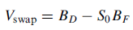
where BF is the value, measured in the foreign currency, of the bond defined by the foreign cash flows on the swap and BD is the value of the bond defined by the domestic cash flows on the swap, and S0 is the spot exchange rate (expressed as number of dollars per unit of foreign currency). The value of a swap can therefore be determined from interest rates in the two currencies and the spot exchange rate.
Similarly, the value of a swap where the foreign currency is received and dollars are paid is
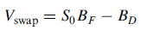
Valuation as Portfolio of Forward Contracts
Each exchange of payments in a fixed-for-fixed currency swap is a forward foreign exchange contract.
The value of a currency swap is normally close to zero initially. If the two principals are worth the same at the start of the swap, the value of the swap is also close to zero immediately after the initial exchange of principal. However, as in the case of interest rate swaps, this does not mean that each of the individual forward contracts underlying the swap has a value close to zero. When interest rates in two currencies are significantly different, the payer of the currency with the high interest rate is in the position where the forward contracts corresponding to the early exchanges of cash flows have negative values, and the forward contract corresponding to final exchange of principals has a positive value. The payer of the currency with the low interest rate is in the opposite position; the forward contracts corresponding to the early exchanges of cash flows have positive values, while that corresponding to the final exchange has a negative value.
Fixed-for-floating where a floating interest rate in one currency is exchanged for a fixed interest rate in another currency
An exchange where sterling LIBOR on a principal of £7 million is paid and 3% on a principal of $10 million is received with payments being made semiannually for 10 years. Similarly to a fixed-for-fixed currency swap, this would involve an initial exchange of principal in the opposite direction to the interest payments and a final exchange of principal in the same direction as the interest payments at the end of the swap’s life. A fixed-for-floating swap can be regarded as a portfolio consisting of a fixed-for-fixed currency swap and a fixed-for-floating interest rate swap. For instance, the swap can be regarded as a swap where 3% on a principal of $10 million is received and 4% on a principal of £7 million is paid plus an interest rate swap where 4% is received and LIBOR is paid on a notional principal of £7 million.
To value the swap we are considering, we can calculate the value of the dollar payments in dollars by discounting them at the dollar risk-free rate. We can calculate the value of the payments by assuming that sterling LIBOR forward rates will be realized and discounting the cash flows at the sterling risk-free rate. The value of the swap is the difference between the values of the two sets of payments using current exchange rates.
Floating-for-floating where a floating interest rate in one currency is exchanged for a floating interest rate in another currency.
This type of swap would be the exchange where sterling LIBOR on a principal of £7 million is paid and dollar LIBOR on a principal of $10 million is received. This would involve an initial exchange of principal in the opposite direction to the interest payments and a final exchange of principal in the same direction as the interest payments at the end of the swap’s life. A floating-for-floating swap can be regarded as a portfolio consisting of a fixed-for-fixed currency swap and two interest rate swaps, one in each currency. For instance, the swap in our example can be regarded as a swap where 3% on a principal of $10 million is received and 4% on a principal of £7 million is paid plus an interest rate swap where 4% is received and LIBOR is paid on a notional principal of £7 million plus an interest rate swap where 3% is paid and LIBOR is received on a notional principal of $10 million.
A floating-for-floating swap can be valued by assuming that forward interest rates in each currency will be realized and discounting the cash flows at risk-free rates. The value of the swap is the difference between the values of the two sets of payments using current exchange rates.
Other Swaps
The instruments exchanged in a swap do not have to be interest payments. Countless varieties of exotic swap agreements exist, but relatively common arrangements include commodity swaps, currency swaps, debt swaps, and total return swaps.
Commodity Swaps
Commodity swaps involve the exchange of a floating commodity price, such as the Brent Crude oil spot price, for a set price over an agreed-upon period. As this example suggests, commodity swaps most commonly involve crude oil.
Currency Swaps
In a currency swap, the parties exchange interest and principal payments on debt denominated in different currencies. Unlike an interest rate swap, the principal is not a notional amount, but it is exchanged along with interest obligations. Currency swaps can take place between countries. For example, China has used swaps with Argentina, helping the latter stabilize its foreign reserves.² The U.S. Federal Reserve engaged in an aggressive swap strategy with European central banks during the 2010 European financial crisis to stabilize the euro, which was falling in value due to the Greek debt crisis.³
Debt-Equity Swaps
A debt-equity swap involves the exchange of debt for equity—in the case of a publicly-traded company, this would mean bonds for stocks. It is a way for companies to refinance their debt or reallocate their capital structure.
Total Return Swaps
In a total return swap, the total return from an asset is exchanged for a fixed interest rate. This gives the party paying the fixed-rate exposure to the underlying asset—a stock or an index. For example, an investor could pay a fixed rate to one party in return for the capital appreciation plus dividend payments of a pool of stocks.
Credit Default Swap (CDS)
A credit default swap (CDS) consists of an agreement by one party to pay the lost principal and interest of a loan to the CDS buyer if a borrower defaults on a loan. Excessive leverage and poor risk management in the CDS market were contributing causes of the 2008 financial crisis.⁴

- Option market, arbitrage
An options contract offers the buyer the opportunity to buy or sell—depending on the type of contract they hold—the underlying asset. Unlike futures, the holder is not required to buy or sell the asset if they decide against it. Each contract will have a specific expiration date by which the holder must exercise their option. The stated price on an option is known as the strike price.
Options are a type of derivative product that allow investors to speculate on or hedge against the volatility of an underlying stock. Options are divided into call options, which allow buyers to profit if the price of the stock increases, and put options, in which the buyer profits if the price of the stock declines. Investors can also go short an option by selling them to other investors. Shorting (or selling) a call option would therefore mean profiting if the underlying stock declines while selling a put option would mean profiting if the stock increases in value.
Option Arbitrage trades are performed to earn small profits with less or zero risk. It is a process of buying and selling an equivalent commodity in two different markets. Options arbitrage can be done through put-call parities. A call gives you the rights to purchase and put gives you the rights to sell.
An important principle in options pricing is called put-call parity. This parity states that the value of a call option, at a specified strike price, implies a particular fair value for the corresponding put option, and vice versa. Thus, the price of a call and put should always hold a price relationship between one another.
The theory behind this pricing relationship relies on the possible arbitrage opportunity that would result if there is a divergence between the value of calls and puts with the same strike price and expiration date. Knowing how these trades work can give you a better feel for how put options, call options, and the underlying stocks intermingle.
What is a Put-Call parity?
- It defines the connection between the worth of put options and call options of an equivalent class, with an equal underlying asset, strike price, and expiration date.
- It also suggests that holding a little put and long call of an equivalent class will deliver an equal return. That is because you are holding one forwarding contract on an identical underlying asset, with an equivalent expiration date and forward price adequate to the Options’ strike price.
- If the costs of the put and call options diverge so that this type of relationship does not hold, an arbitrage opportunity exists, because the traders can theoretically earn a risk-free profit
- The equation expressing put-call parity is c + K^e-rt = p+S
Where,
c= Call price
K = Strike Price
p = Put price
S= Initial price of underlying
r= Rate of interest
t= Time of expiry
e-rt = Discounting factor
If this equality is violated there is an arbitrage opportunity

Adjustments for American Options
This pricing relationship was developed to describe European-style options, but the concept also applies to American-style options, adjusting for dividends and interest rates.
If the dividend increases, the puts expiring after the ex-dividend date will rise in value, while the calls will decrease by a similar amount. Changes in interest rates have the opposite effects. Rising interest rates increase call values and decrease put values.
The Synthetic Position
Option-arbitrage strategies involve what are called synthetic positions. All of the basic positions in an underlying stock, or its options, have a synthetic equivalent. What this means is that the risk profile (the possible profit or loss), of any position, can be exactly duplicated with other, but, more complex strategies. The rule for creating synthetics is that the strike price and expiration date, of the calls and puts, must be identical.
For creating synthetics, with both the underlying stock and its options, the number of shares of stock must equal the number of shares represented by the options. To illustrate a synthetic strategy, consider a fairly simple option position: the long call. When you buy a call, your loss is limited to the premium paid while the possible gain is unlimited. Now, consider the simultaneous purchase of a long put and 100 shares of the underlying stock. Once again, your loss is limited to the premium paid for the put, and your profit potential is unlimited if the stock price goes up. Below is a graph that compares these two different trades.
If the two trades appear identical, that's because they are. While the trade that includes the stock position requires considerably more capital, the possible profit and loss of a long-put/long-stock position is nearly identical to owning a call option with the same strike and expiration. That's why a long-put/long-stock position is often called a "synthetic long call." In fact, the only difference between the two lines, above, is the dividend that is paid during the holding period of the trade. The owner of the stock would receive that additional amount, but the owner of a long call option would not.
Arbitrage Using Conversion and Reversals
You can use this idea of the synthetic position to explain two of the most common arbitrage strategies: the conversion and the reverse conversion (often called simply by reversal). The reasoning behind using synthetic strategies for arbitrage is that since the risks and rewards are the same, a position and its equivalent synthetic should be priced the same.
A conversion involves buying the underlying stock, while simultaneously buying a put and selling a call. (The long-put/short-call position is also known as a synthetic short stock position.) For a reverse conversion, you short the underlying stock while simultaneously selling a put and buying a call (a synthetic long stock position). As long as the call and put have the same strike price and expiration date, a synthetic short/long stock position will have the same profit/loss potential as shorting/owning 100 shares of stock (ignoring dividends and transaction costs).
Remember, these trades guarantee a profit with no risk only if prices have moved out of alignment, and the put-call parity is being violated. If you placed these trades when prices are not out of alignment, all you would be doing is locking in a guaranteed loss. The figure below shows the possible profit/loss of a conversion trade when the put-call parity is slightly out of line.
This trade illustrates the basis of arbitrage – buy low and sell high for a small, but fixed, profit. As the gain comes from the price difference, between a call and an identical put, once the trade is placed, it doesn't matter what happens to the price of the stock. Because they basically offer the opportunity for free money, these types of trades are rarely available. When they do appear, the window of opportunity lasts for only a short time (i.e. seconds or minutes). That's why they tend to be executed primarily by market makers, or floor traders, who can spot these rare opportunities quickly and do the transaction in seconds (with very low transaction costs).
- Option pricing
Types of options
Bermudan option
A Bermudan option is an option that gives the holder the right to exercise a set number of times. These options fall between European and American options.
Bermudan options allow investors to buy or sell an underlying asset or security at a pre-set price. However, it does not specify a single date or allow exercise at any time. Instead, it sets several dates along the expiration date to exercise.
Asian option
Asian options are options where the payoff depends on the arithmetic average of the price of the underlying asset during the life of the option.
We have two types of Asian Options
Fixed Strike
Here, the strike price is constant while the stock average price varies. See in the excel file
Fixed Price
We use the Stock price at maturity and stock average price. We do not use strike price here. See in the excel file.
American option
American options can be exercised at any time up to the expiration date.
European Option
European options can be exercised only on the expiration date itself.
European options are generally easier to analyse than American options.
Binomial model
A useful and very popular technique for pricing an option involves constructing a binomial tree. This is a diagram representing different possible paths that might be followed by the stock price over the life of an option. The underlying assumption is that the stock price follows a random walk. In each time step, it has a certain probability of moving up or down by a certain percentage amount.
The binomial distribution would tell us the different probabilities of diferrent stages.
It’s a European call option with strike price is 100, sigma (volatility per annum) is 0.3, delta t is 0.083 equal 1 month, risk free interest rate is 5%, pup is the probability of option price going up (0.75 in this case) and pdown vice versa, u (positive growth factor) is exponential of sigma times sqrt dt and d (negative growth factor) is 1 over u (or exponential of minus sigma times sqrt dt), a is growth factor for risk free account per period (exponential of dt times r), q is risk neutral probability (a-d/u-d)

We calculate the prices basically by mutiply previous S with the up and down factor. Then calculate the future call option price by taking the maximum strike price minus K and times call/put factor. Next, we discount risk neutral expected value from later period to get the option values by using q
Black Scholes
Using the Black Scholes differential equation, we can value our option. The differential equation for the price of any derivative dependent on a stock can be obtained by creating a riskless portfolio of the derivative and the stock. Because the derivative’s price and the stock price both depend on the same underlying source of uncertainty, this can always be done. The portfolio that is created remains riskless for only a very short period of time. However, the return on a riskless portfolio must always be the risk-free interest rate if there are to be no arbitrage opportunities. The expected return on the stock does not enter into the Black–Scholes–Merton differential equation. This leads to an extremely useful result known as risk-neutral valuation. This result states that when valuing a derivative dependent on a stock price, we can assume that the world is risk neutral. This means that we can assume that the expected return from the stock is the risk-free interest rate, and then discount expected payoffs at the risk-free interest rate. The Black–Scholes–Merton equations for European call and put options can be derived by either solving their differential equation or by using risk-neutral valuation
BS equation:
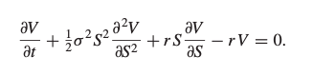
1. Start with S as GBM
2. Introduce Option price as V
3. Use Ito Lemma to obtain the PDE of option price
4. Make a protfolio: Option - delta * Stocks
5. Calculate the change in value of the portfolio
CRUCIAL: choose delta in a way to eliminate risk ==> eliminate dS (change in stock price)
==> risk-free portfolio, has to behave like one ==> grows with the risk free interest rate
===> substitute and find the BS formula
The BS equation is the PDE
The BS formula is the price (solution to the PDE)
Important detail: how can you solve the BS specifically for a call option?
===> The PDE itself does not lead directly to the value, the derivative’s payout function is needed
Boundary conditions!

The Black-Scholes formula result can be derived from BS equation.
Monte Carlo Pricing
Monte Carlo simulation involves using random numbers to sample many different paths that the variables underlying the derivative could follow in a risk-neutral world. For each path, the payoff is calculated and discounted at the risk-free interest rate. The arithmetic average of the discounted payoffs is the estimated value of the derivative.
When used to value an option, Monte Carlo simulation uses the risk-neutral valuation result. We sample paths to obtain the expected payoff in a risk-neutral world and then discount this payoff at the risk-free rate. Consider a derivative dependent on a single market variable S that provides a payoff at time T. Assuming that interest rates are constant, we can value the derivative as follows:
1. Sample a random path for S in a risk-neutral world.
2. Calculate the payoff from the derivative.
3. Repeat steps 1 and 2 to get many sample values of the payoff from the derivative in a risk-neutral world.
4. Calculate the mean of the sample payoffs to get an estimate of the expected payoff in a risk-neutral world.
5. Discount this expected payoff at the risk-free rate to get an estimate of the value of the derivative.
MC is applied when we do European option, some simple options that not past dependent. We are interested in the distr of the underlying price at maturity, that’s what we do in excel sheet. We take the GBM model and generate few scenarios like 1000 in this sheet. For each we generate std random number, and then using GBM fomular to stimulate stock price which is ST. (S0 times exponential of (r-D-sig²/2)*T-t plus sigma Wt which is sqrt of T-t times N(0,1). This is Weiner process value at maturity and this is a random number. We can generate a series of 1000 random ST. Based on that, we can calculate payout value for the option and discounted payout. We calculate it with diferrent strike prices.
- Black-Scholes-Merton model and the Greeks
How the Black-Scholes Model Works

Black-Scholes posits that instruments, such as stock shares or futures contracts, will have a lognormal distribution of prices following a random walk with constant drift and volatility. Using this assumption and factoring in other important variables, the equation derives the price of a European-style call option.

The Black-Scholes equation requires five variables. These inputs are volatility, the price of the underlying asset, the strike price of the option, the time until expiration of the option, and the risk-free interest rate. With these variables, it is theoretically possible for options sellers to set rational prices for the options that they are selling.
Furthermore, the model predicts that the price of heavily traded assets follows a geometric Brownian motion with constant drift and volatility. When applied to a stock option, the model incorporates the constant price variation of the stock, the time value of money, the option's strike price, and the time to the option's expiry.
BS equation:

1. Start with S as GBM
2. Introduce Option price as V
3. Use Ito Lemma to obtain the PDE of option price
4. Make a protfolio: Option - delta * Stocks
5. Calculate the change in value of the portfolio
CRUCIAL: choose delta in a way to eliminate risk ==> eliminate dS (change in stock price)
==> risk-free portfolio, has to behave like one ==> grows with the risk free interest rate
===> substitute and find the BS formula
The BS equation is the PDE
The BS formula is the price (solution to the PDE)
Important detail: how can you solve the BS specifically for a call option?
===> The PDE itself does not lead directly to the value, the derivative’s payout function is needed
Boundary conditions!
Black-Scholes Assumptions
The Black-Scholes model makes certain assumptions:
- No dividends are paid out during the life of the option.
- Markets are random (i.e., market movements cannot be predicted).
- There are no transaction costs in buying the option.
- The risk-free rate and volatility of the underlying asset are known and constant.
- The returns on the underlying asset are log-normally distributed.
- The option is European and can only be exercised at expiration.

While the original Black-Scholes model didn't consider the effects of dividends paid during the life of the option, the model is frequently adapted to account for dividends by determining the ex-dividend date value of the underlying stock. The model is also modified by many option-selling market makers to account for the effect of options that can be exercised before expiration
What Are the Limitations of the Black-Scholes Model?
The Black-Scholes model is only used to price European options and does not take into account that American options could be exercised before the expiration date. Moreover, the model assumes dividends, volatility, and risk-free rates remain constant over the option's life.
Not taking into account taxes, commissions or trading costs or taxes can also lead to valuations that deviate from real-world results.
Greeks
Delta:
The delta of an option is the sensitivity of the option price to a change in the price of the underlying stock price.
The call and put curves do not intersect and the range of call value is from 0 to1; the range of put value is from -1 to 0
Gamma:
The gamma of an option is the sensitivity of the option’s delta to a change in the price of the underlying stock price.
The gamma curve looks like a normal distribution
The value of gamma is typically positive reflecting the gains the portfolio receives from holding the option
Theta:
The theta of an option is the sensitivity of the option price to a negative change in time-to-maturity
The value of theta is typically negative because the value of the option decreases as time moves closer to expiration
Other Greeks that do not appear in the BS Equation:
Vega: sensitivity measure on volatility. Vega hedging is relevant when volatility is high.
Rho: sensitivity measure on interest rate

- Risk management at financial institutions, regulation
Risk vs uncertainty
• Risk: more, but known possible future outcomes with given probabilities; the distribution is known.
• Uncertainty: more possible future outcome, but the probablities or even all the possible outcomes are unknown.
Risk attitude Two possibilities: a certain and a risky choice with the same expected value. Risk averse:prefers the certain option.
Risk neutral: indifferent between the two options.
Risk seeker: prefers the risky option.
Certainty equivalent CE is the certain amount of money the decision maker would accept instead of the risky bet.
Risk averse:CE is lower than the expected value of the risky choice
Risk neutral: CE equals the expected value
Risk seeker: CE is higher than the expected value of the risky choice
Risk of an investment Investors are interested in the return of their investment.

Riskless investment: 100->105
Risky investment 100 could either get 130 or 90

Measuring risk A risk measure characterizes the distribution of the risk factor (return of the investment).
◦ Standard deviation /variance
◦ Quantile (percentile)
◦ Maximum /minimum
Risk-return trade-off in investments There is a trade off between risk and expected return The higher the risk, the higher the expected return
Basel standars
Basel I. – credit risk 1996: Amendment – market risk of the trading book 2004:
Basel II. – operational risk 2009: Basel II.5 – market risk revisited
Basel III. – liquidity risk, systemic risk
Capital Requirement Regulation (CRR) Calculation of own funds requirements:
- standardized approach (risk weights are set by the regulator)
- internal model based calculations
The Question Being Asked in VaR- “What loss level is such that we are X% confident it will not be exceeded in N business days?”
VaR and Regulatory Capital
- Regulators have traditionally used VaR to calculate the capital they require banks to keep
- The market-risk capital has been based on a 10-day VaR estimated where the confidence level is 99%
- Credit risk and operational risk capital are based on a one-year 99.9% VaR
Advantages of VaR
- It captures an important aspect of risk
in a single number
- It is easy to understand
- It asks the simple question: “How bad can things get?”
VaR vs. Expected Shortfall
- VaR is the loss level that will not be exceeded with a specified probability
- Expected shortfall (ES) is the expected loss given that the loss is greater than the VaR level (also called C-VaR and Tail Loss)
- Regulators have indicated that they plan to move from using VaR to using ES for determining market risk capital
- Two portfolios with the same VaR can have very different expected shortfalls
Coherent Risk Measures (page 274-275)
- Define a coherent risk measure as the amount of cash that has to be added to a portfolio to make its risk acceptable
- Properties of coherent risk measure
  - If one portfolio always produces a worse outcome than another its risk measure should be greater
  - If we add an amount of cash K to a portfolio its risk measure should go down by K
  - Changing the size of a portfolio by l should result in the risk measure being multiplied by l
  - The risk measures for two portfolios after they have been merged should be no greater than the sum of their risk measures before they were merged
VaR vs Expected Shortfall
- VaR satisfies the first three conditions but not the fourth one
- ES satisfies all four conditions.
Spectral Risk Measures
- A spectral risk measure assigns weights to quantiles of the loss distribution
- VaR assigns all weight to Xth percentile of the loss distribution
- Expected shortfall assigns equal weight to all percentiles greater than the Xth percentile
- For a coherent risk measure weights must be a non-decreasing function of the percentiles
Normal Distribution Assumption
- When losses (gains) are normally distributed with mean mu and standard deviation sigma
Back-testing (page 285-288)
● Back-testing a VaR calculation methodology involves looking at how often exceptions (loss > VaR) occur
● Alternatives: a) compare VaR with actual change in portfolio value and b) compare VaR with change in portfolio value assuming no change in portfolio composition
● Suppose that the theoretical probability of an exception is p (=1−X). The probability of m or more exceptions in n days is
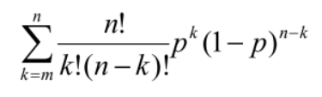
- Corporate risk management
Based on file 6_handout:
- - ERM --- presentation
- - Elements of ERM --- presentation
- - Risk appetite --- presentation
- - Corporate risk management --- BINUS university web
- - Cash-flow at Risk --- wikipedia
- - Earning at Risk --- investopedia
ERM:
Definition: Enterprise risk management is a process, effected by an entity’s board of directors, management, and other personnel, applied in strategy setting and across the enterprise, designed to identify potential events that may affect the entity, and manage risk to be within its risk appetite, to provide reasonable assurance regarding the achievement of entity objectives.
Elements of ERM:
- Board involvement
- Part of company’s strategy and help a company achieve its objectives
- Identify adverse events
- Manage risks consistently with risk appetite
Risk appetite:
- Regulators require banks to develop risk appetite frameworks
How much loss at what confidence level are we prepared to risk
What reputation risk are we prepared to take
What credit rating risk are we prepared to take
How concentrated should we allow our risks to become. etc
- Key risk appetite question could be: What is the return, R, that we want to be exceeded with a high probability p
- If R_{M} is the return from the market, R_{F} is the risk- free return, and s_{M} is the standard deviation of the return from the market, then the beta of the portfolio should be 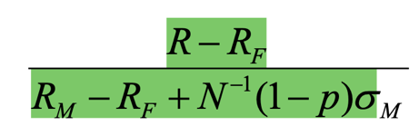
Corporate risk management:
Corporate risk management is defined as a set of financial and operational activities that maximize the value of a company or a portfolio by reducing the costs associated with risk (Stulz, 1996, 2003).
The main risk management activities are diversification and risk hedging using various instruments, including derivatives and structured products, market insurance, self-insurance, and self-protection. The main costs firms seek to minimize are costs of financial distress, risk premium to partners (stakeholders), expected income taxes, and investment financing. Managers’ behavior toward risk (risk appetite and risk aversion) and corporate governance also affect the choice of risk management activities.
Cash-flow at Risk:
Cash Flow at Risk or CFaR is an important tool in corporate risk management. According to the definition of CFaR: under normal circumstances, at a given level of significance, a minimum required cash flow over a given time horizon / time.
While Value at Risk (VaR), which is an easy-to-understand but incoherent measure of risk, has become more widespread in banking practice, CFaR based on expected future cash flows has spread in corporate practice because:
• companies to raise more time-consuming resources than banks. If the company does not receive a loan, does not pay its suppliers, a debt is formed. Liquidity problems for companies can involve significant risks and costs, so they focus on CFaRs
• in addition, banks are more flexible in terms of liquidity than companies, they can easily obtain funds on the interbank market, but due to the rapid revaluation of balance sheet items, the change in the market value and risk of portfolios, the VaR measure, is more important.
Earning at Risk:
Earnings at risk (EAR) is the amount of change in net income due to changes in interest rates over a specified period. It helps investors and risk professionals understand the impact that a change in interest rates can make on a company's financial position and cash flow.

EAR calculation includes balance sheet items that are considered sensitive to changes in interest rates and generate income or expense cash flows. For example, a bank may have 95% confidence that the deviation from expected earnings due to changes in interest rates will not exceed a certain number of dollars throughout a certain period. This is its earnings at risk.

Summary ---- Hull’s book
Enterprise risk management is an attempt to take a holistic approach to risk management rather than addressing risk in silos. The central idea is that business units within the financial institution should be part of an integrated, strategic, and enterprise-wide risk management system. The risk appetite for the organization should be defined at the top and approved by the board. Steps should then be taken to ensure that the management of different types of risks in different business units is consistent with the overall risk appetite framework.
A financial institution’s risk appetite statement should define how much risk the organization is prepared to take in pursuit of its objectives. Some aspects of the risk appetite, such as the amount of capital the financial institution is prepared to risk los- ing, can be expressed quantitatively. Others, such as risks to reputation, are likely to be expressed qualitatively. The risk appetite must then be converted into directives for the risks taken by business units. Appropriate limits are then set on trading risk, how con- centrated the financial institution’s portfolio can become, how much credit risk can be taken, and so on. The risks being taken should be continually monitored to ensure that they are consistent with the financial institution’s risk appetite.
Developing a good risk culture is an important part of ERM. A key element of the risk culture is ensuring that medium- to long-term risks are considered when opportu- nities that offer short-term profits are evaluated. There are many examples of financial institutions aggressively pursuing short-term profits when the activity being undertaken has led several years later to serious problems such as lawsuits, fines, or a loss of reputation. The bonus structure within financial institutions has in the past encouraged employees to use the maximization of short-term profits as their sole criterion for decision making. Since the 2008 credit crisis, there have been attempts to change this culture by introduc- ing deferred bonuses and clawbacks.
It is important for a financial institution to develop procedures for identifying worst- case outcomes. Unfortunately, there are many biases that are liable to cause managers to misjudge future outcomes and their probabilities of occurring. Once the risks being taken have been identified, it is important to actively manage the risks. Sometimes it will be necessary to discontinue certain activities; sometimes risks can be shared (e.g., with insurance or joint ventures); sometimes steps can be taken to reduce the impact of the risks; and sometimes risks can be accommodated within the organization’s risk appetite.
- Corporate valuation: the present value approach
g = (Noplat_{t} /Noplat_{t}-1)-1
Noplat_{t} = EBIT_{t} * (1 – Tax rate)
Noplat_{t} = ∆invested Capital_{t}/K_{t}
K_{t} = ∆Invested Capital_{t}/Noplat_{t}
K_{t} = g_{t+1}/RONIC_{t+1}
ROIC_{t} = Noplat_{t}/ Invested Capital_{t-1}
RONIC_{t} = ∆Noplat_{t}/ ∆Invested Capital_{t-1}
FCFF_{t} = NOPLAT_{t} - ∆Invested Capital_{t}
FCFF_{t} = NOPLAT_{t} - NOPLAT_{t} * K_{t}
FCFF_{t} = NOPLAT_{t} * (1 - K_{t})
FCFF = FCFD + FCFE
FCFD = ∆Debt_{t} – Interest + Tax shield (TS)
FCFE = ∆Equity_{t} (Required Equity) – Retained Earnings - Dividends
EVA = Actual Profit from operations – Required Profit from Invested Capital
= NOPLAT_{t} - (IC_{t-1} * WACC_{t})
= IC_{t-1} * (ROIC_{t} – WACC_{t})
RI = Actual Profit for the year for equity holders – Required Profit by equity Holders
= PAT – (BV.Equity_{t-1} * rE)
= BV.Equity_{t-1} * (ROE_{t} – rE_{t})
rA = D/V * rD + E/V * rE
WACC = D/V * rD* (1 – Tax rate) + E/V * rE
WACC = rA - D/V * rD *t
rE = (rA - D/V * rD) / (1-D/V)

DCF Models
Entity Model (V – D = E) | Equity Model (E)
FCFF | FCFE
APV | RI
EVA

Model | Cost of Capital/Discount rate | Formula | Terminal Period
FCFF | WACC | SUM(FCFF/(1+WACC)) | FCFF/(WACC-g)
APV | rA | SUM((FCFF+TS)/(1+rA)) | (FCFF+TS)/(rA-g)
FCFE | rE | SUM(FCFE/(1+rE)) | FCFE/(rE-g)
EVA | WACC | SUM(EVA/(1+WACC)) + ICboy = Vboy | Vboy – ICboy = NOPLAT/WACC
RI | rE | SUM(RI/(1+rE)) + BV.Equity = Eboy | Eboy – BV.Equity = PAT/rE

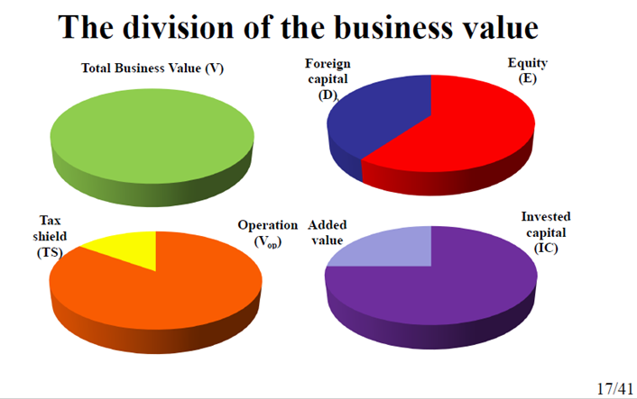
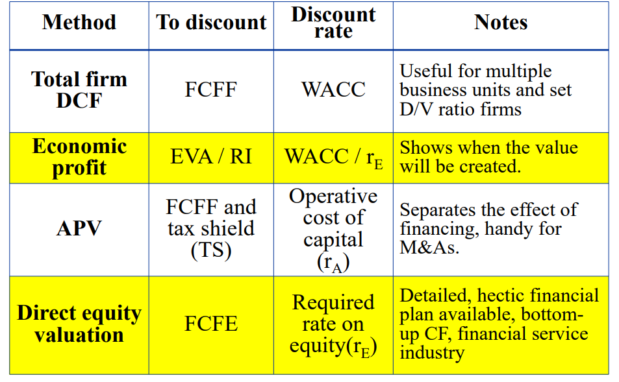

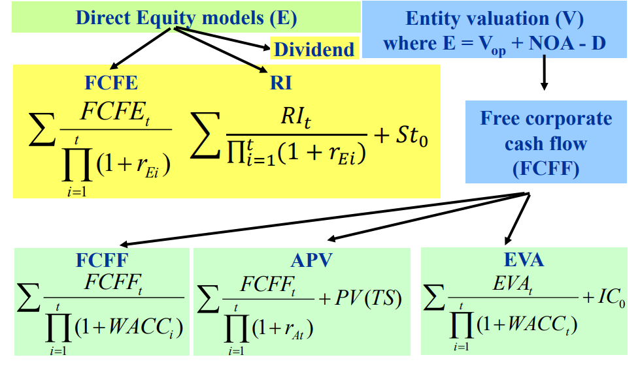
Why do we have various DCF methods? When is it most handy to use one or the other?
The reason we have various DCF methods - which should all theoretically result in the exact same value based on MM theorems - is because the total business value can be dissected in more than one way.
The Total firm DCF method is used when multiple business units should be valued and when D/V ratio could be assumed, as it is essential for WACC calculation (discount rate used for this method).
Based on the Direct Equity Valuation model, Equity and Foreign capital (i.e. Debt) are the two components that make up the total firm value. This model is useful when a detailed financial plan is available or when a bottom-up CF approach should be followed. It is also widely used in the financial service industry.
APV separates the effect of financing by assuming the total value to be composed of the Operational value (FCFF) and the Tax shield (TS). This method is handy for M&As.
Economic profit models such as EVA and RI show when the value will be created.
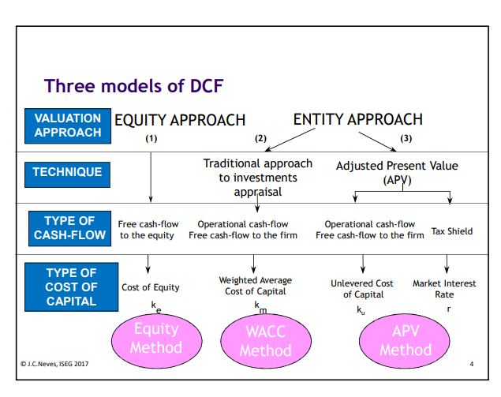
If the treatment of hybrid securities will make a material difference in valuation results,30 we recommend using adjusted present value (APV). In the APV model, enterprise value is determined by discounting free cash flow at the industry-based unlevered cost of equity. The value of incremental cash flows related to financing, such as interest tax shields, is then computed separately.
Free cash flow (FCF) models measure how cash flows in and out of the company, regardless of accounting. Economic profit links better to value creation. Implemented correctly, both models will lead to the same valuation result.
Exhibit H.16: Enterprise DCF Valuation. To arrive at the present value of cash flow, we sum each year’s discounted FCF with the discounted value of continuing value. Then we adjust the resulting value by half a year to estimate the value of operations, reflecting that cash flows are generated throughout the year. To the value of operations, we add any nonoperating assets that are excluded from free cash flow—in this case, excess cash and the value of tax loss carryforwards. For simplicity, we value tax loss carryforwards at book value less the valuation allowance.
Valuation Using Economic Profit. To determine the value of operations, add discounted economic profit to invested capital. As expected, an economic-profit-based valuation leads to the same value of operations as an enterprise DCF valuation.

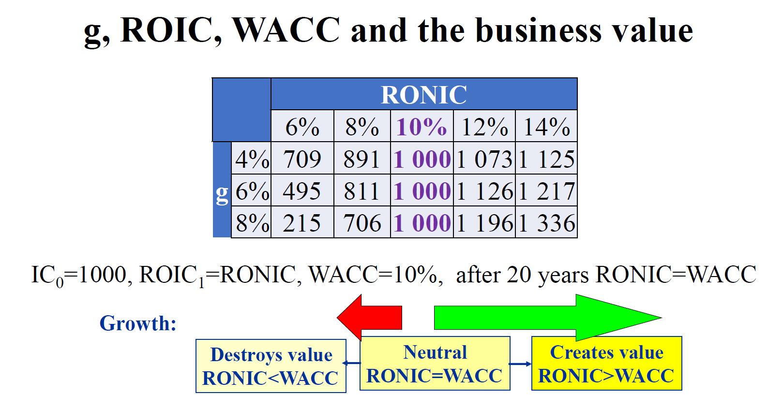

- Corporate valuation: relative multiples approach and other alternatives
Grouping the mutlple: profit, revenue, asset, industry based
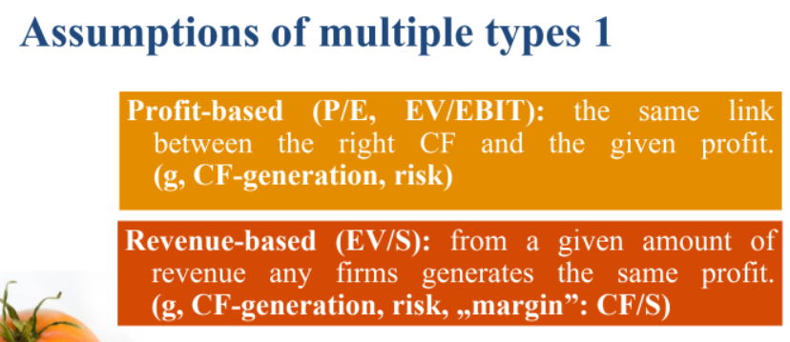
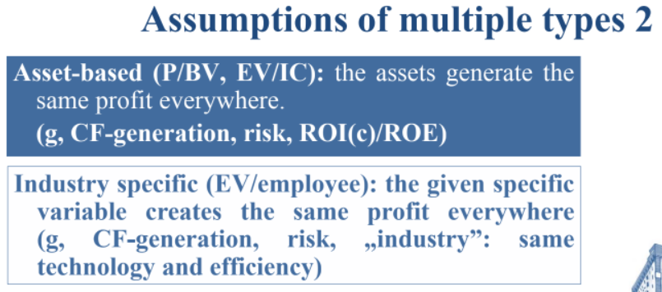
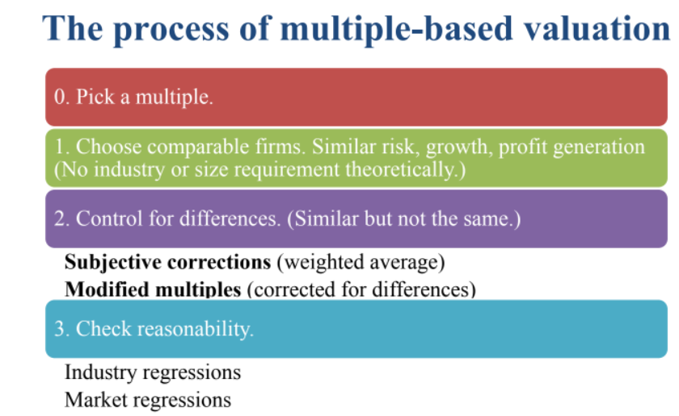
- Cost of capital (theory and practice)
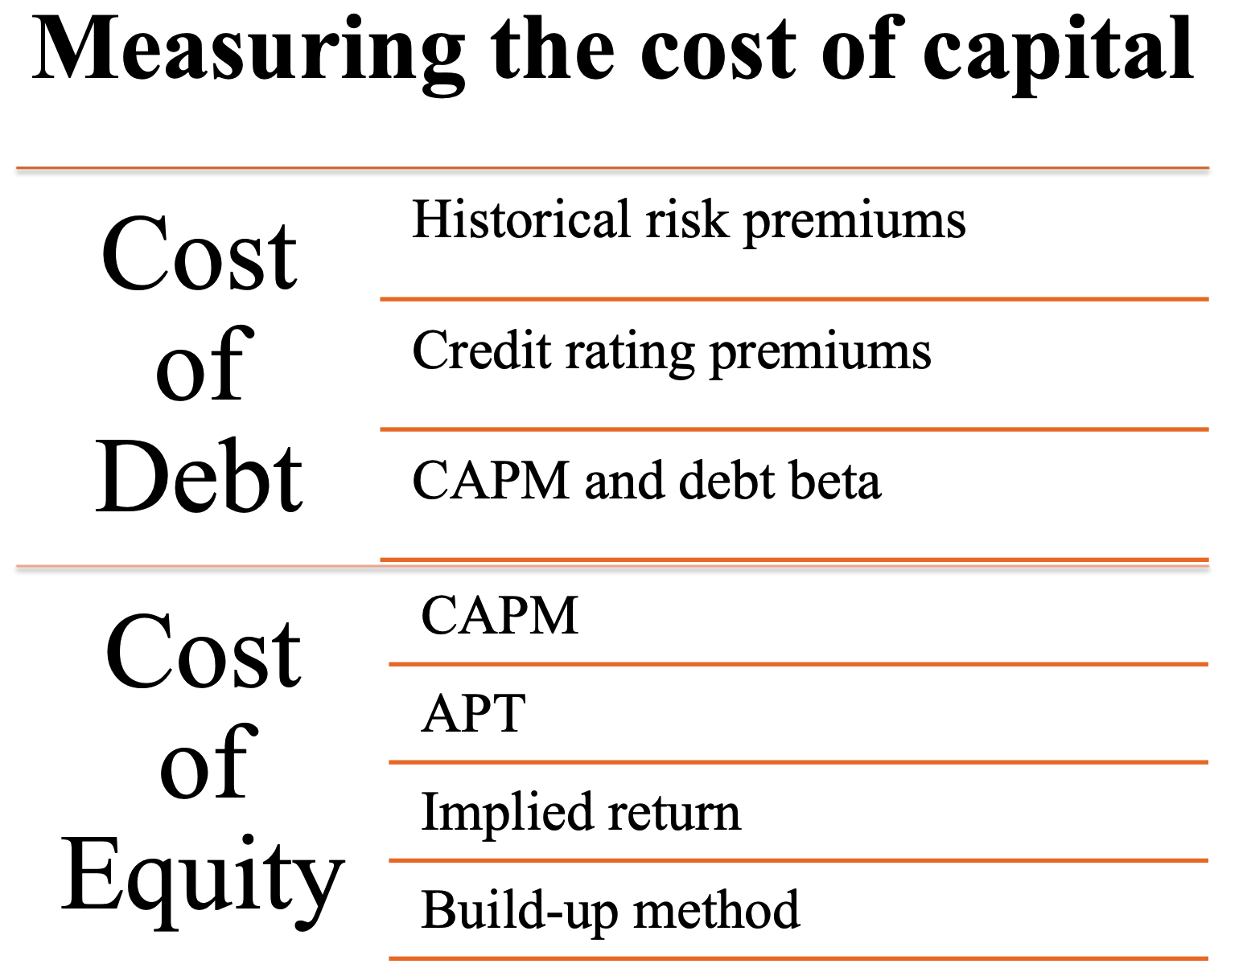
A company’s cost of capital is critical for determining value creation and for evaluating strategic decisions. It is the rate at which you discount future cash flows for a company or project. It is also the rate you compare with the return on invested capital to determine if the company is creating value. The cost of capital incorporates both the time value of money and the risk of investment in a company, business unit, or project.
The cost of capital is not a cash cost. It is an opportunity cost. To illustrate, when one company acquires another company, the alternative might have been to return that cash to shareholders, who could then reinvest it in other companies. So the cost of capital for the acquiring company is the price investors charge for bearing risk— what they could have earned by reinvesting the proceeds in other investments with similar risk.
To value a company using enterprise discounted cash flow (DCF), discount your forecast of free cash flow (FCF) at the weighted average cost of capital (WACC). The WACC represents the returns that all investors in a company—equity and debt—expect to earn for investing their funds in one particular business instead of others with similar risk. The investment return they are forgoing is also referred to as their opportunity cost of capital. Since a company’s investors will earn the cost of capital if the company meets expectations, the cost of capital is used interchangeably with expected return.
Calculating Cost of Capital with WACC

What Is the Weighted Average Cost of Capital (WACC)?
WACC is the average after-tax cost of a company’s various capital sources, including common stock, preferred stock, bonds, and any other long-term debt. In other words, WACC is the average rate a company expects to pay to finance its assets.
Since a company’s financing is largely classified into two types—debt and equity—WACC is the average cost of raising that money, which is calculated in proportion to each of the sources.
WACC is a formula that gives insight into how much interest a company owes for each dollar it finances. Analysts use WACC to assess the value of an investment. WACC is a key number used in discounted cash flow (DCF) analysis. Company management also uses WACC figures as a hurdle rate when choosing which projects to undertake. Meanwhile, investors will use WACC when assessing whether an investment is viable.
The WACC formula includes the weighted average cost of equity plus the weighted average cost of debt.
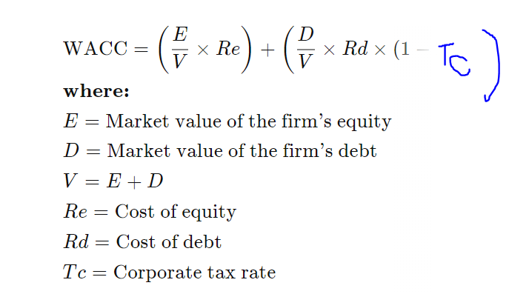

The WACC has three primary components: the cost of equity, the after-tax cost of debt, and the company’s target capital structure. Estimating WACC with precision is difficult because there is no way to directly measure an investor’s opportunity cost of capital, especially the cost of equity.
The most common model used to adjust the cost of equity for differences in risk is the capital asset pricing model (CAPM). Other models include the Fama-French three-factor model and the arbitrage pricing theory (APT). The three models differ primarily in which factors are used to estimate the effect of compensated risk. Despite extensive criticism of the CAPM, we believe that it remains the best model to adjust for risk. In the CAPM, the beta of an investment is the risk that the investment adds to a market portfolio. In the APM and multifactor model, the betas of the investment relative to each factor have to be measured.
To estimate the cost of debt for investment-grade companies, use the yield to maturity of the company’s long-term, option-free bonds. Multiply your estimate of the cost of debt by 1 minus the marginal tax rate to determine the cost of debt on an after-tax basis. Yield to maturity is only a proxy for expected return, because the yield is a promised rate of return on a company’s debt; it assumes all coupon payments are made on time and the debt is paid in full.
- Mergers and acquisitions, and their financing
Mergers and acquisitions (M&A) are an important element of a dynamic economy. At different stages of an industry’s or a company’s life span, resource decisions that once made economic sense no longer do. For instance, the company that invented a groundbreaking innovation may not be best suited to exploit it. As demand falls off in a mature industry, companies are likely to have built excess capacity. At any time in a business’s history, one group of managers may be better equipped to manage the business than another. At moments like these, acquisitions are often the best or only way to reallocate resources sensibly and rapidly.
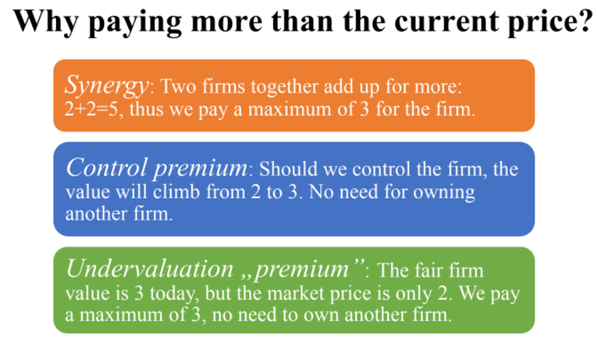
Premium | + | - | Who pays it
Undervaluation | Intrinsic value of target | Market price of target | The buyer is ready to pay this amount on the top of  the market price.
Control | Intrinsic value of target when optimally managed | Market price of the target with the current management | A buyer with better management skills is ready to pay that above the market value.
Synergy | Intrinsic value of the merged firm | Stand alone values of both firms when optimally managed | – A buyer owning another company that could generate synergies.  – Usually just shared. There is no need to pay this completely.
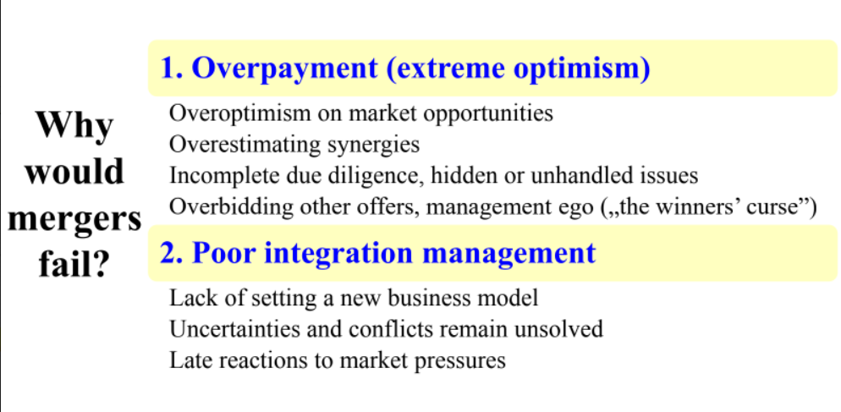
- Capital structure policy
The relative proportions of debt, equity, and other securities that a firm has outstanding constitute its capital structure. When corporations raise funds from outside investors, they must choose which type of security to issue. The most common choices are financing through equity alone and financing through a combination of debt and equity.
Many financial managers use weighted average calculations as part of the business’s capital structure policy because it factors in the cost of raising each type of capital. A business may be able to secure more funds by leveraging debt than by offering stock, but, due to interest and repayment fees, the debt might cost more in the long term. Or, it might not. Weighing each source of capital with its cost offers insight into the true value of money from each source of funds within the capital structure.
Equity in a firm with no debt is called unlevered equity.
Equity in a firm that also has debt outstanding is called levered equity.
The problem is, that the risk is increasing for the levered equity because Payments to debt holders are made before payments to equity holders. However, The relationship between risk and return can be evaluated by compute the sensitivity of each security’s return to the systematic risk of the economy and showing that - The debt’s return bears no systematic risk, its risk premium is zero while the levered equity has higher the systematic risk of the unlevered equity and, as a result, higher the risk premium.
Capital markets are said to be perfect if they satisfy three conditions:
- Investors and firms can trade the same set of securities at competitive market prices equal to the present value of their future cash flows.
- There are no taxes, transaction costs, or issuance costs associated with security trading.
- A firm’s financing decisions do not change the cash flows generated by its investments, nor do they reveal new information about them.
Modigliani and Miller (MM) I. proposition: leverage, arbitrage and firm value
In a perfect capital market, the total value of a firm is equal to the market value of the total cash flows generated by its assets and is not affected by its choice of capital structure.
Because: the total cash flow paid out to all of a firm’s security holders is equal to the total cash flow generated by the firm’s assets. -> by the Law of One Price, the firm’s securities and its assets must have the same total market value.
Modigliani and Miller (MM) II. proposition: leverage, risk and the cost of capital
The cost of capital of levered equity increases with the firm’s market value debt-equity ratio.
In the imperfection marktet, Corporations must pay taxes on the income that they earn. Because they pay taxes on their profits after interest payments are deducted, interest expenses reduce the amount of corporate tax firms must pay. This feature of the tax code creates an incentive to use debt.
In general, the gain to investors from the tax deductibility of interest payments is referred to as the interest tax shield. The interest tax shield is the additional amount that a firm would have paid in taxes if it did not have leverage. We can calculate the amount of the interest tax shield each year as follows:
Interest Tax Shield = Corporate Tax Rate * Interest Payments
Each year a firm makes interest payments, the cash flows it pays to investors will be higher than they would be without leverage by the amount of the interest tax shield:
Cash Flows to Investors with Leverage = Cash Flows to Investors without Leverage + (Interest Tax Shield)
- Long-term financing of corporations
Raising equity capital
When a private company decides to raise outside equity capital, it can seek funding from several potential sources: angel investors, venture capital firms, institutional investors, and corporate investors.
Angel investors / angel groups:
Individuals who buy equity in small private firms.
Venture capital firms:
A limited partnership that specializes in raising money to invest in the private equity of young firms
General partners are running the business 🡪 venture capitalist
Advantages to angels for limited partners:
- More diversified portfolios
- Benefit from the expertise of the GPs.
GPs charge large fees:
- 20% of any positive return
- Annual management fee app. 2%
Private equity firms:
They finance mainly privately held firms rather than start-ups.
Leveraged buyout (LBO) 🡪 buying publicly held firms.
Instituational investors:
Pension funds, insurance companies, endowments, foundations (directly, or through VC-s/PE-s)
Corporate investors ( = corporate partner, strategic partner, strategic investors)
Venture Capital Investing
When a company founder decides to sell equity to outside investors for the first time, it is common practice for private companies to issue preferred stock rather than common stock to raise capital. Preferred stock issued by mature companies usually has preferential dividend, liquidation, or voting rights relative to common shareholders. While the preferred stock issued by young companies typically does not pay regular cash dividends, it usually gives the owner the option to convert it into common stock, and so is called convertible preferred stock. If the company runs into financial difficulties, the preferred stockholders have a senior claim on the assets of the firm relative to any common stockholders (who are often the employees of the firm). If things go well, then these investors will convert their preferred stock and receive all the rights and benefits of common stockholders. Each time the firm raises money is referred to as a funding round, and each round will have its own set of securities with special terms and provisions.
The value of the prior shares outstanding at the price in the funding round is called the pre-money valuation. The value of the whole firm (old plus new shares) at the funding round price is known as the post-money valuation. The difference between the pre-and post-money valuation is the amount invested. In other words,
Post-money Valuation = Pre-money Valuation + Amount Invested (23.1)
In addition, the fractional ownership held by the new investors is equal to
Percentage Ownership = Amount Invested/Post-money Valuation
Leasing
Besides debt financing, leasing could be used to implement an investment project, a firm must acquire the necessary property, plant, and equipment. As an alternative to purchasing these assets outright, the firm can lease them.
A lease is a contract between two parties: the lessee and the lessor. The lessee is liable for periodic payments in exchange for the right to use the asset. The lessor is the owner of the asset, who is entitled to the lease payments in exchange for lending the asset.
Most leases involve little or no upfront payment. Instead, the lessee commits to make regular lease (or rental) payments for the term of the contract. At the end of the contract term, the lease specifies who will retain ownership of the asset and at what terms. The lease also specifies any cancellation provisions, the options for renewal and purchase, and the obligations for maintenance and related servicing costs.
The cost of the lease will depend on the asset’s residual value, which is its market value at the end of the lease.
In a perfect capital market (where lessors compete with one another in initiating leases), the lease payment should be set so that the NPV of the transaction is zero and the lessor breaks even:
PV(Lease Payments) = Purchase Price - PV(Residual Value)
- Short-term financing of corporations
Working capital management
NWC is the capital required on the short term to run the business.
Main components are cash, inventory, receivables, payables.
A firm’s cash cycle is the length of time between when the firm pays cash to purchase its initial inventory and when it receives cash from the sale of the output produced from that inventory.
The cash conversion cycle (CCC) is defined as
CCC = Accounts Receivable Days + Inventory Days - Accounts Payable Days
The firm’s operating cycle is the average length of time between when a firm originally purchases its inventory and when it receives the cash back from selling its product. If the firm pays cash for its inventory, this period is identical to the firm’s cash cycle. However, most firms buy their inventory on credit, which reduces the amount of time between the cash investment and the receipt of cash from that investment.
When a firm allows a customer to pay for goods at some date later than the date of purchase, it creates an account receivable for the firm and an account payable for the customer. Accounts receivable represent the credit sales for which a firm has yet to receive payment. The accounts payable balance represents the amount that a firm owes its suppliers for goods that it has received but for which it has not yet paid. The credit that the firm is extending to its customer is known as trade credit.
Benefits of Trade Credit. For a number of reasons, trade credit can be an attractive source of funds. First, trade credit is simple and convenient to use, and it therefore has lower transaction costs than alternative sources of funds. For example, no paperwork must be completed, as would be the case for a loan from a bank. Second, it is a flexible source of funds, and can be used as needed. Finally, it is sometimes the only source of funding available to a firm.
Short-term financial planning
Firms require short-term financing for
- Seasonalities:
When sales are concentrated during a few months, sources and uses of cash are also likely to be seasonal.
- Negative/positive cash flow shocks:
Occasionally, a company will encounter circumstances in which cash flows are temporarily negative for an unexpected reason, creating a short-term financing need, or positive because of eg. sales growth which needs an initial investment.
In reality, one transaction cost is the opportunity cost of holding cash in accounts that pay little or no interest. Firms also face high transaction costs if they need to negotiate a loan on short notice to cover a cash shortfall. Firms can increase their value by adopting a policy that minimizes these kinds of costs. One such policy is known as the matching principle. The matching principle states that short-term needs should be financed with short-term debt and long-term needs should be financed with long-term sources of funds.
Permanent Working Capital:
The amount that a firm must keep invested in its short-term assets to support its continuing operations -> the firm should finance this permanent investment in working capital with long-term sources of funds.
Temporary Working Capital:
The difference between the actual level of short-term working capital needs and its permanent working capital requirements. -> the firm should finance this temporary investment in working capital with short-term sources of funds.
The most common short-term financing source is loan with loan stipulations and fees such as commintment fee (The commitment fee associated with a committed line of credit, which increases the effective cost of the loan to the firm.), loan origiantion fee (A bank charge that a borrower must pay to initiate a loan. A loan origination fee reduces the amount of usable proceeds that the firm receives and increases the effective cost of the loan), compensating balance requirement (instead of loan origination fee, bank can require the firm keep an amount equal to eg. 10% of the loan principal in a non-interest-bearing account with the bank as long as the loan remains outstanding)
- Financial distresses at corporations
Financial distress: when a firm has trouble meeting its debt obligation.
A firm that fails to make the required interest or principal payments on the debt is in default. After the firm defaults, debt holders are given certain rights to the assets of the firm. In the extreme case, the debt holders take legal ownership of the firm’s assets through a process called bankruptcy. The equity financing does not carry this risk. While equity holders hope to receive dividends, the firm is not legally obligated to pay them.
Bankruptcy: Complex, time-consuming, costly
direct costs: legal and accounting experts, consultants, other administrative costs
indirect cost: loss of costumers/suppliers/employers/receivables, fire sales of assets, cost to crediters, inefficient liquidation
When securities are fairly priced, the original shareholders of a firm pay the present value of the costs associated with bankruptcy and financial distress.
Trade-off theory I.
The firm picks its capital structure by trading off the benefits of the tax shield from debt against the costs of financial distress and agency costs.
The total value of a levered firm equals the value of the firm without leverage plus the present value of the tax savings from debt, less the present value of financial distress costs.
Vl = Vu + PV (Interest Tax Shield) (Financial Distress Costs)
Calculating the precise present value of financial distress costs is quite complicated. Three key factors determine the present value of financial distress costs: (1) the probability of financial distress, (2) the magnitude of the costs if the firm is in distress, and (3) the appropriate discount rate for the distress costs.
- Lending at commercial banks, the lending products

Information Asymmetry
First to mention is the information asymmetry between the lender and the creditors. The potential debtor strives to convince the bank, that its creditworthiness is acceptable, while the bankers try to explore all obvious or hidden risk factors, exposures. At the same time, most pieces information stem from the company, from its management, or owners.
The contact persons and analysts in the bank will never reach their level of information, it must work from secondary sources most of the time. Under these circumstances, the bankers must make an optimal decision: assuming a given risk level it must approve the “good” and reject the “bad” loans.
Two different parts of the organization mandate processing and approval in lending. The “front-office” (the sales) is responsible for the client acquisition and hasten to acquire new and good quality clients at an acceptable risk level at an adequate price. On the back-office side, the risk analysts at the risk department are responsible to manage the risk level, which corresponds to the overall credit strategy of the bank. Their positive decision is indispensable for the final approval of the loan.

The Loan Procedure
In the first phase, there is the formal contact between the debtor and the financial institution. A contact is usually via a front-office employee of the bank. Before the contact, the relationship manager usually makes some preliminary screening of the potential targets.
Then the credit officer tries to collect all necessary information to understand and analyze, the business model, the operation, the objective of financing, and related risk factors. This is a kind of due diligence process. If the decision is supportive, then it could be confirmed to the debtor in the form of a special document and letter called „firm offer”, „firm commitment”. This is similar in form to the indicative offer, contains all important parameters, terms and conditions of the loan, however, the signing and issuance of such a letter incorporates a legal commitment for the bank. The bank is obliged to provide the loan if the conditions of the issued offer are fulfilled. The next step is contracting, that is preparing the credit contract, agreeing in form and content. There is usually a bundle of contracts to sign: the credit contract, collateral contracts, bailment contracts, sureties, possible other agreements, and statements.
The provision of the loan does not mark the end of bank’s procedure. There must be continuous monitoring of the loans outstanding from the relationship management’s and from the risk analyst’s sides as well. The bank must review every loan annually (not just the short term but also long-term loans) in the framework of the annual review.
Collaterals
Guarantee
Suretyship
Comfort letters are declarations in different forms usually issued by companies, institutions who support the borrower to pay its obligation.
Insurance
Assignment of claims, receivables
Pledge
Bailment
Option rights
A collateral pool agreement can solve these obstacles. The banks sign a multilateral agreement, acknowledged by the borrower, that collaterals are put in a pool.

Covenants
Though collaterals do not reduce the probability of default, the covenants do. The covenants usually take up a dominant part of the credit contracts formulated in clauses and standard wording and define different types of contractual obligations of the borrower.
Cross default, change of control, pari passu, negative pledge etc
- Financial statement analysis
Financial statements: accounting reports with past performance information that a firm issues periodically.
1. Balance sheet (BS)
2. Income statement (IS)
3. Statement of cash flows (CF)
4. Statement of stockholders’ equity
- Balance sheet:
1. Net working capital = current assets – current liabilites
Important: cash that is not needed for the everyday operation is not part of the NWC.
2. Market value vs book value of equity difference is because book value shows the historical costs
3. Market value of equity (E) = market capitalization = shares outstanding x market price per share
Enterprise value (EV) = Market value of equity + Debt – cash
Working capital ratio: AR days (the speed at which a company turns sales into cash), AP days, Inventory days
Liquidity ratio: current ratio, quick ratio, cash ratio
- Income statement:
Profitability ratio: Gross margin (ability to sell a product for more than the cost of production), operating margin (efficiency of operation), EBIT margin (efficiency of operation), Net profit margin (shows the fraction of each dollar in revenues that is available for equity holders)
Interest coverage ratio: EBIT/Interest coverage, EBITDA/Interest coverrage
- Statement of cashflow
Utilizes the information from the BS and IS to determine how much cash the firm has generated, and how the cash has been allocated during a set period.
FCFF = FCFD + FCFE
FCFF = Free Cash Flow to Firm = EBIT x (1-tax rate) – change in net working capital – change in long-term assets
FCFE = Free Cash Flow to Equity = dividend payment + stock repurchase –stock sales
FCFD = change in debt + interest payment
- Statement of Stockholders’ Equity & Other
Breaks down the stockholders’ equity computed on the BS into the amount that came from issuing shares versus retained earnings.
Change in shareholders’ equity = retained earnings + Net sales of stocks = Net income – dividends + sales of stocks – repurchase of stocks
Also:
Leverage ratio
Debt-Equity ratio = Total Debt / Total Equity
Debt-to-Capital ratio = Total Debt / (Total Equity + Total Debt)
Net Debt = Total Debt – Excess cash and short-term investment
Debt-to-Enterprise value = Net Debt / (Market Value of Equity + Net Debt)
Equity multiplier = Total Assets / Book value of Equity
Valuation ratio
Price-earnings (P/E) = Market capitalizationt-1/ Net incomet = Share pricet-1/ EPSt
Sensitive to the choice of leverage, and depreciation and amortization.
EV / Sales
EV / EBITDA
EV/EBIT
Operating return
Return on Equity (ROE) = Net Incomet/ Book Value of Equityt-1
ROE provides a measure of the return that the firm has earned on its past investments.
Return on Assets (ROA) = (Net Income + Interest expense)t/ Book Value of Assetst-1
Return on Invested Capital (ROIC) = EBIT x (1 – tax rate)t/ (Book Value of Equityt-1 +Net Debtt-1)

